**LESSON 1 : HEAT**

Heat is a form of **energy** that transfers from one object or substance to another due to a difference in temperature. It is associated with the random motion of particles within matter, such as atoms and molecules.

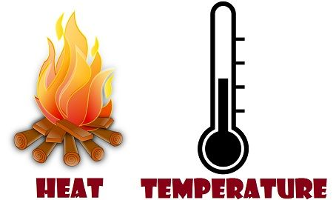



Temperature is a measure of the average **kinetic energy** (motion) of the particles in a substance. It indicates how hot or cold an object or environment is.

MODES OF HEAT TRANSFER

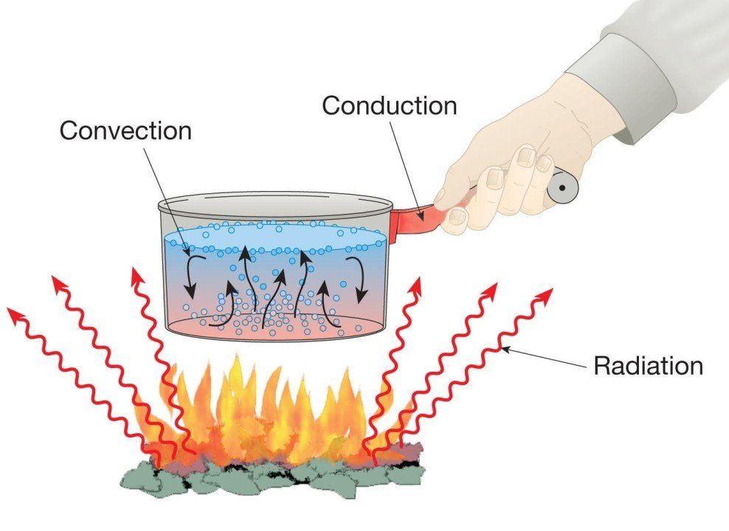

RADIATION OF HEAT

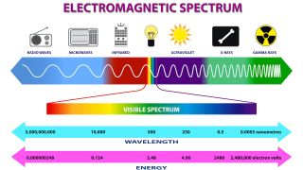

HEAT MANAGEMENT IN COMPUTERS

is crucial for maintaining system performance, longevity, and reliability. Heat is generated by the operation of components like the CPU, GPU, and power supply, and if not managed properly, it can lead to overheating, reduced efficiency, or hardware failure.

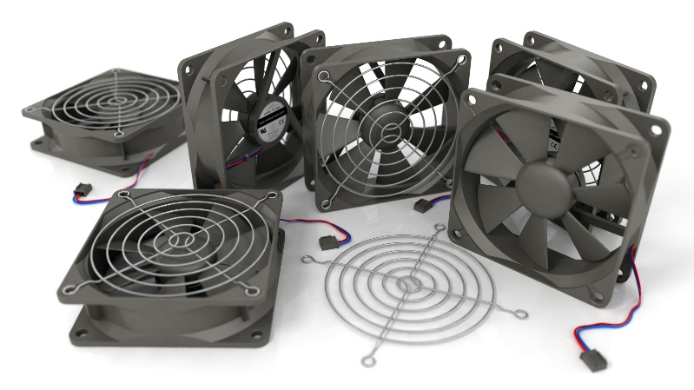

HEAT SINK

is a device designed to dissipate heat from a heat-generating component, such as a CPU, GPU, or power transistor, to maintain safe operating temperatures. It works by increasing the surface area available for heat dissipation and transferring the heat away from the source into the surrounding environment.

